100W LED MOVING HEAD
USER MANUAL
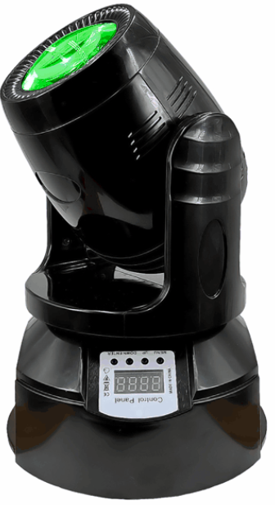

LED-150BSW

Please read and keep this manual carefully for further use!

Thank you for buying our professional Beam moving head.
This user manual includes important information for installation and operation, so please read this user manual carefully before installation and operation, and keep this user manual well for further use.
In order to install , operate, and maintain the lighting safety and correctly. We suggest that the installation and operation should be done by the verified technician and follow the instruction strictly.
Spare part includes:
Name | QTY | Unit
Fixture | 1 | PC
User manual | 1 | PC
Power cable | 1 | PC
Bracket | 1 | PCS
Safety rope | 1 | PC

Please check carefully that there is no damage caused by transportation. Should there be any, consult your local dealer.
Cautions
Before delivery, this device has passed strict inspection, Please follow the user manual strictly for operation, if this fixture is damaged by improper operation and mistake, the fixture will be out of warranty, and manufacture or dealer won’t be responsible for it. In case of any technology change in this manual,we won’t advise in further .



CAUTION!

Keep this device away from rain and moisture!

Unplug mains lead before opening the housing!

Warning!

Silkscreen symbol on light
Damages caused by the disregard of this user manual are not subject to warranty. The dealer will not accept liability for any resulting defects or problems.

Installation
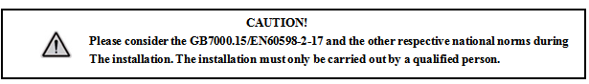

► This fixture is not suitable for direct installation on combustible material surface, please keep the fixture surface at least 0.5m from any combustible material.

► If you use the quick lock cam in hanging up the fixture, please make sure the quick lock fasteners turned in the quick lock holes correctly.
►The applicable temperature for the fixture is between -25°C to 45°C. Do not use the lighting under or above this temperature range.
►The truss for hanging the fixture should be able to hold 10 times weight of this fixture and no deformation after 1 hour hang.
►Please don’t stand under the fixture when install, uninstall, move or repair the fixture.
►Please ensure the light is connected correctly and invite professional technician to check and confirm the electrical data before installation.
►Please invite professional technician to check the fixture and installation each year.
Rigging：

Insert the quick-lock fasteners of the first holder into the respective holes on the bottom of the device.Tighten the quick-lock fasteners fully clockwise.
Fix the clamp on truss or other fixture bracket.
Pull the safety rope through the holes on the bottom of the base and fasten it on the truss or other fixing point.
Note:This step is quite important to ensure that fixture will not drop down for the clamp damage.

Product specification

Voltage：100-240V，50/60HZ；
Power Consumption：100W；
Lamp: LED
DMX Channel: 9/13CH
Control mode: DMX512/Master-slave/Auto/Sound
Pan：630°；
Tilt：200°；
electronic focus,with RDM
Electrical dimming：0%~100%；
Beam angle：2º;
Strobe:1-23HZ
Display：LED display

Display and operation
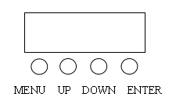
MENU | Select function
UP | Parameters increment
DOWN | Decreasing parameters
ENTER | Confirm and save

Display Setting:
Addr | 1-512 | DMX address
Chnd | 13ch | 13CH mode
Chnd | 9ch | 9CH mode
Slnd | Sl01 | Slave mode
Slnd | Auto | Auto mode
Slnd | Sound | Sound control
Shnd | Sh 0 | Show 1
Shnd | Sh 1 | Show 2
Shnd | Sh 2 | Show 3
Shnd | Sh 3 | Show 4
Sens | 10-100 | Sound sensitivity
Led | OFF | Screen saver off
Led | ON | Screen saver on
Disp | OFF | Screen reverse off
Disp | ON | Screen reverse on
rPan | OFF | Pan reverse off
rPan | ON | Pan reverse on
rtiL | OFF | Tilt reverse off
rtiL | ON | Tilt reverse on
Rest | YES | Reset
tenp | xxx | Temperature detection

9/13 DMX channel Table
13CH | 9CH | Function | Value | Description
1 | 1 | Dimming | 0-255 | Total dimming
2 | 2 | Strobe | 0-10 | No strobe
2 | 2 | Strobe | 11-255 | Strobe from slow to fast
3 | 3 | Pan | 0-255 | Pan
4 |  | Pan fine | 0-255 | Pan fine
5 | 4 | Tilt | 0-255 | Tilt
6 |  | Tilt fine | 0-255 | Tilt fine
7 | 5 | Pan/Tilt speed | 0-255 | Speed from slow to fast
8 | 6 | Color | 0-9 | White
8 | 6 | Color | 10-19 | Color 1
8 | 6 | Color | 20-29 | Color 2
8 | 6 | Color | 30-39 | Color 3
8 | 6 | Color | 40-49 | Color 4
8 | 6 | Color | 50-59 | Color 5
8 | 6 | Color | 60-69 | Color 6
8 | 6 | Color | 70-79 | Color 7
8 | 6 | Color | 80-149 | Half-color
8 | 6 | Color | 150-255 | Color flowing forward
9 | 7 | Gobo | 0-9 | White
9 | 7 | Gobo | 10-19 | Gobo 1
9 | 7 | Gobo | 20-29 | Gobo 2
9 | 7 | Gobo | 30-39 | Gobo 3
9 | 7 | Gobo | 40-49 | Gobo 4
9 | 7 | Gobo | 50-59 | Gobo 5
9 | 7 | Gobo | 60-69 | Gobo 6
9 | 7 | Gobo | 70-79 | Gobo 7
9 | 7 | Gobo | 80-89 | Gobo 8
9 | 7 | Gobo | 90-99 | Gobo 9
9 | 7 | Gobo | 80-149 | Gobo shake
9 | 7 | Gobo | 150-255 | Gobo flowing forward
10 | 8 | Prism | 0-127 | Prism Off
10 | 8 | Prism | 128-156 | Prism On
10 | 8 | Prism | 157-255 | Prism rotation
11 |  | Auto | 0-29 | No effect
11 |  | Auto | 30-59 | Auto 1
11 |  | Auto | 60-89 | Auto 2
11 |  | Auto | 90-119 | Auto 3
11 |  | Auto | 120-149 | Auto 4
11 |  | Auto | 150-179 | Sound 1
11 |  | Auto | 180-209 | Sound 2
11 |  | Auto | 210-239 | Sound 3
11 |  | Auto | 240-255 | Sound 4
12 |  | Auto speed | 0-255 | Speed from slow to fast
13 | 9 | Reset | 0-249 | No effect
13 | 9 | Reset | 250-255 | Reset after 3 seconds

DMX-512 connection

Connect the provided XLR cable to the male 3-pin XLR output of your controller and the other side to the female 3-pin XLR input of the light.then connect the DMX signal to the first fixture to the 2nd fixture, after all fixtures are connected,

The signal cable should be two - core with screened cable with XLR input and output connectors. Please refer to the diagram below

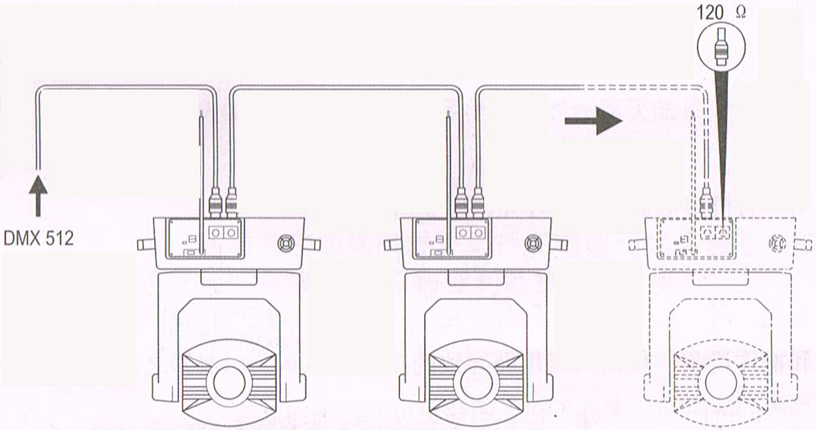

DMX terminator connection
If there are many lines or lights, it is recommended to use a DMX terminator to prevent DMX signal corruption, the DMX terminator is an simple XLR plug with a 120 Ω resistor connected between pins 2 and 3,which is then plugged into the output XLR socket of the last fixture in the chain.

3-Pins connection
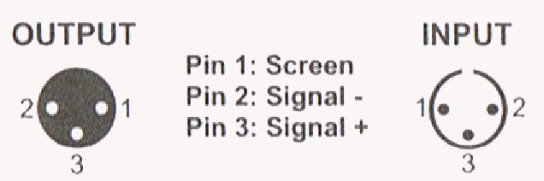
DMX Address setting
Each fixture must set a specific starting address. When receiving signal transmission, fixture will receive channel control signals which from the starting address.
According to different requirements or easy to use, the user can set many value fixtures to the same address, also can set up a separate address for every device.
If you set the same address,all the devices will receive from DMX channels signal. All connecting fixtures are jointly controlled, controller can't separate control a device.
If you set a different address, each device will be separate from its particular set the starting address and begin accepting DMX512 control signal, so that more convenient separate control one device. Using this method must be based on channel quantity of device to determine a starting address.
This light has 13 channels.you should set the starting address of the first unit to 1, the second unit to 14(1 + 14), the third unit to 27 (14+ 13), and so on.

Cleaning and maintenance

Cleaning should be performed every 15-day period, by using a sponge which is dipped with alcohol, rather than wet cloth or other chemical liquid, to clean the mirror.

Cut off power before cleaning and maintenance!
CAUTION

Attention

Do not see directly light source when open the light, and make sure power off before do any installation or maintenance.


 Wires connection must be done professional person!
CAUTION

Cautions
Before delivery, this device has passed strict inspection, Please follow the user manual strictly for operation, if this fixture is damaged by improper operation and mistake, the fixture will be out of warranty, and manufacture or dealer won’t be responsible for it. In case of any technology change in this manual,we won’t advise in further .

Common issues instruction

Issues | Solve instruction
No power | Check power’s voltage
When power in, output light but the device cannot accept control signal | Check address setting and the control DMX cable connection well or not
The effect have light shadow | Check electronic focus DMX channel value, does suitable distance
Power down | The lamp maybe arrived end of using life, should change new lamp, and also check light source cleaning or not
Note: the maintenance should be done by the verified technician.

Warranty Card
This product is made of high-brightness transistor. We will provide 1 year warranty under the condition that user has operated the light normally and lifetime service. We won't provide warranty if the damage is caused by artificial or force majeure event. Cost of fittings should be charged by user if product need maintenance after 1 year .Please cut this warranty card and shipped it along with the product to our factory when applying for warranty.
Product：
Purchasing date：
Code of invoice：
Warranty date: From To
User’s name： Add：
Company： Tel：

